**EXPERIMENT 11**

**Aim:**

Tounderstand the Subnetting Scenario.

**Software Used:** Cisco Packet Tracer

**Topology:**

**Objectives:**

Part 1: Design an IP Addressing Scheme

Part 2: Assign IP Addresses to Network Devices and Verify Connectivity

**Questions based on this activity are:**

Q1: Based on the topology, how many subnets are needed?

Ans: 5 Four for the LANS, and one for the link between the routers.

Q2: How many bits must be borrowed to support the number of subnets in the topology table?

Ans: 3

Q3: How many subnets does this create?

Ans: 8

Q4: How many usable hosts does this create per subnet?

Ans: 30

**Addressing Table**-

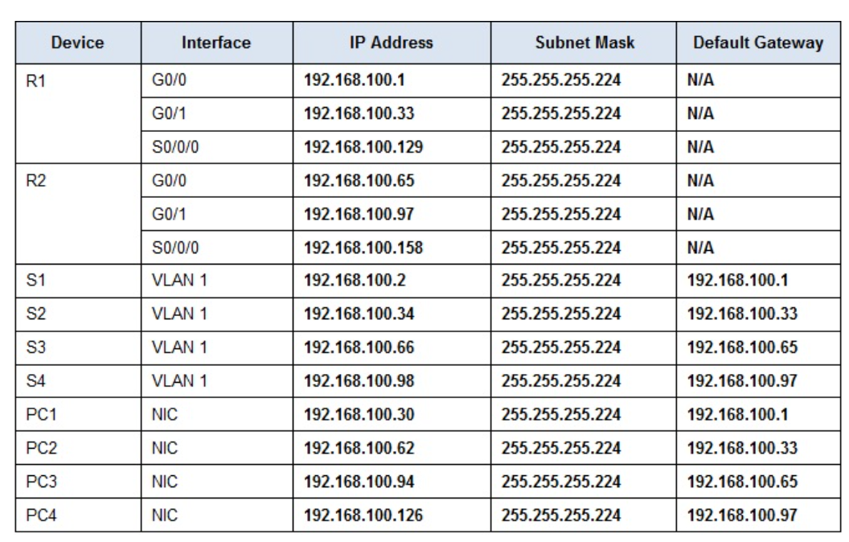

**Part 1: Design an IP Addressing Scheme**

Step 1: Subnet the 192.168.100.0/24 network into the appropriate number of subnets.

**Subnet Table -**

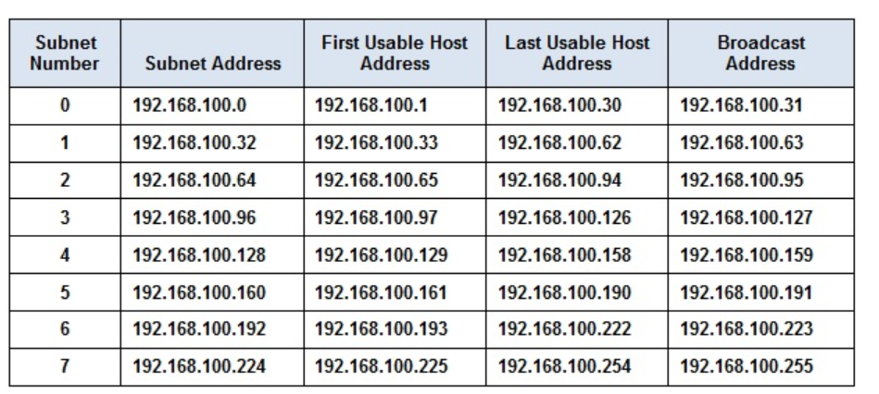

Step 2: Assign the subnets to the network shown in the topology.

Step 3: Document the addressing scheme.

**Part 2: Assign IP Addresses to Network Devices and Verify Connectivity**

Step 1: Configure R1 LAN interfaces.

Step 2: Configure IP addressing on S3.

Step 3: Configure PC4.

Step 4: Verify connectivity.

**Result**-

**EXPERIMENT 12**

**Aim:**

To study VLSM Design and Implementation.

**Software Used**:Cisco Packet Tracer

**Topology**:

**Objectives-**

Part 1: Examine the Network Requirements

Part 2: Design the VLSM Addressing Scheme

Part 3: Assign IP Addresses to Devices and Verify Connectivity

**Questions related to this activity are:**

Q1: How many subnets are needed in the network topology?

Ans: 5

Q2: Which subnet mask will accommodate the number of IP addresses required for ASW-1?

Ans: 255.255.255.240/24

Q3: How many usable host addresses will this subnet support?

Ans: 14 (10.11.48.97-10.11.48.110)

Q4: Which subnet mask will accommodate the number of IP addresses required for ASW-2?

Ans: 255.255.255.224 /27

Q5: How many usable host addresses will this subnet support?

Ans: 30 (10.11.48.65-10.11.48.94)

Q6: Which subnet mask will accommodate the number of IP addresses required for ASW-3?

Ans: 255.255.255.248/29

Q7: How many usable host addresses will this subnet support?

Ans: 6 (10.11.48.113-10.11.48.118)

Q8: Which subnet mask will accommodate the number of IP addresses required for ASW-4?

Ans: 255.255.255.192/26

Q9: How many usable host addresses will this subnet support?

Ans: 62 (10.11.48.1-10.11.48.62)

Q10: Which subnet mask will accommodate the number of IP addresses required for the connection between Building I and Building??

Ans: 255.255.255.252/30

**Addressing Table**

| **Device** | **Interface** | **Address** | **Subnet Mask** | **Default Gateway** |
| --- | --- | --- | --- | --- |
| Branch 1 | G0/0 | 192.168.72.129 | 255.255.255.240 | N/A |
| G0/1 | 192.168.72.97 | 255.255.255.224 | N/A |
| S0/0/0 | 192.162.72.145 | 255.255.255.252 | N/A |
| Branch2 | G0/0 | 192.168.72.65 | 255.255.255.248 | N/A |
| G0/1 | 192.168.72.1 | 255.255.255.192 | N/A |
| S0/0/0 | 192.168.72.146 | 255.255.255.252 | N/A |
| Room-114 | VLAN 1 | 192.168.72.130 | 255.255.255.240 | 192.168.72.129 |
| Room-279 | VLAN 1 | 192.168.72.96 | 255.255.255.224 | 192.168.72.97 |
| Room-312 | VLAN 1 | 192.168.72.66 | 255.255.255.248 | 192.168.72.65 |
| Room-407 | VLAN 1 | 192.168.72.2 | 255.255.255.192 | 192.168.72.1 |
| PC-A | NIC | 192.168.72.142 | 255.255.255.240 | 192.168.72.129 |
| PC-B | NIC | 192.168.72.126 | 255.255.255.224 | 192.168.72.97 |
| PC-C | NIC | 192.168.72.94 | 255.255.255.248 | 192.168.72.65 |
| PC-D | NIC | 192.168.72.62 | 255.255.255.192 | 192.168l.72.1 |

**Instructions**

**Part 1: Examine the Network Requirements**

Step 1: Determine the number of subnets needed.

You will subnet the network address **192.168.72.0/24**. The network has the following requirements:

·         **Room-114** LAN will require **7** host IP addresses

·         **Room-279** LAN will require **15** host IP addresses

·         **Room-312** LAN will require **29** host IP addresses

·         **Room-407** LAN will require **58** host IP addresses

Step 2: Determine the subnet mask information for each subnet.

**Part 2: Design the VLSM Addressing Scheme**

Step 1: Divide the 192.168.72.0/24 network based on the number of hosts per subnet.

a.     Use the first subnet to accommodate the largest LAN.

b.     Use the second subnet to accommodate the second largest LAN.

c.     Use the third subnet to accommodate the third largestLAN.

d.     Use the fourth subnet to accommodate the fourth largestLAN.

e.     Use the fifth subnet to accommodate the connection between **Branch1**and**Branch2**.

Step 2: Document the VLSM subnets.

Step 3: Document the addressing scheme.

a.     Assign the first usable IP addresses to **Branch1** for the two LAN links and the WAN link.

b.     Assign the first usable IP addresses to **Branch2** for the two LAN links. Assign the last usable IP address for the WAN link.

c.     Assign the second usable IP addresses to the switches.

d.     Assign the last usable IP addresses to the hosts.

**Part 3: Assign IP Addresses to Devices and Verify Connectivity**

Most of the IP addressing is already configured on this network. Implement the following steps to complete the addressing configuration.

Step 1: Configure IP addressing on the Branch1 router LAN interfaces.

Step 2: Configure IP addressing on the Room-312, switch including the default gateway.

Step 3: Configure IP addressing on PC-D, including the default gateway.

Step 4: Verify connectivity.

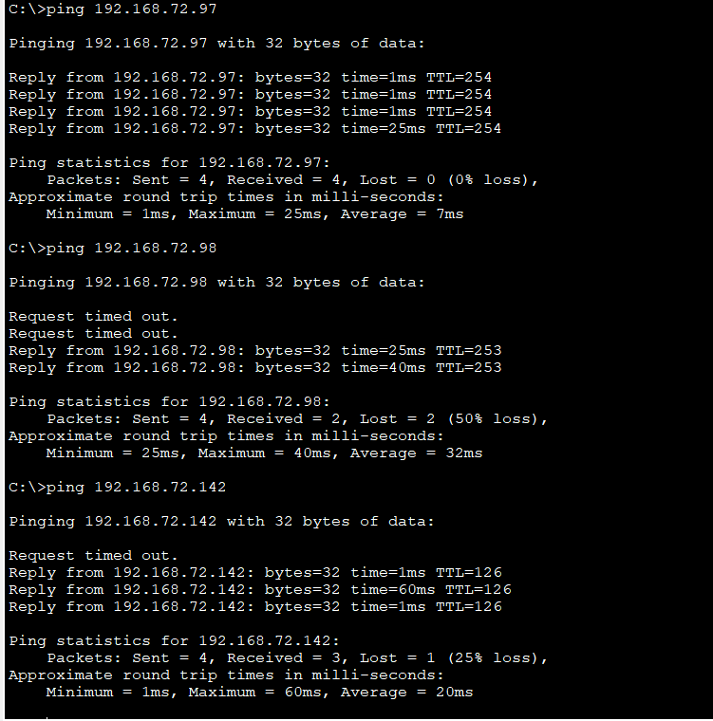

**Result-** Hence we have studied the VLSM Design and Implementation.



**EXPERIMENT 13**

**Aim**:

To implement a subnetted IPv6 addressing scheme.

**Software Used**:Cisco Packet Tracer

**Topology**:

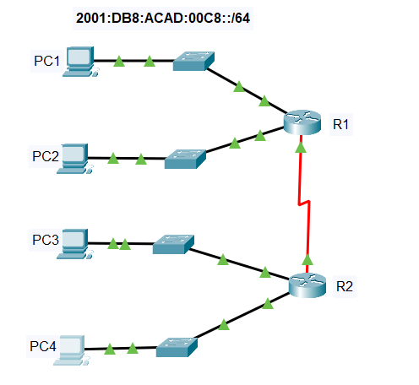

**Addressing Table**-

**Objectives-**

Step 1: Determine IPv6 subnets and addressing scheme.

Step 2: Configure IPv6 addressing on routers and PCs.

Step 3: Verify IPv6 connectivity

**Instructions -**

Step 1: Determine IPv6 subnets and addressing scheme.

Step 2: Configure IPv6 addressing on routers and PCs.

Step 3: Verify IPv6 connectivity.

**CLI Mode of R1**-

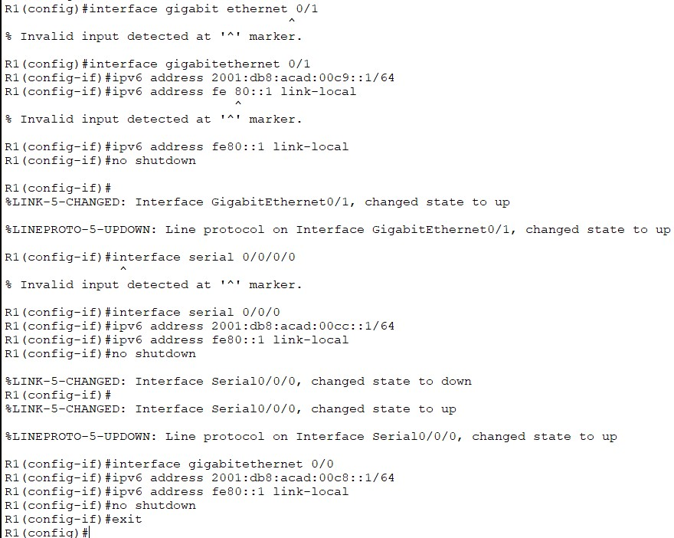

**CLI Mode Of R2-**

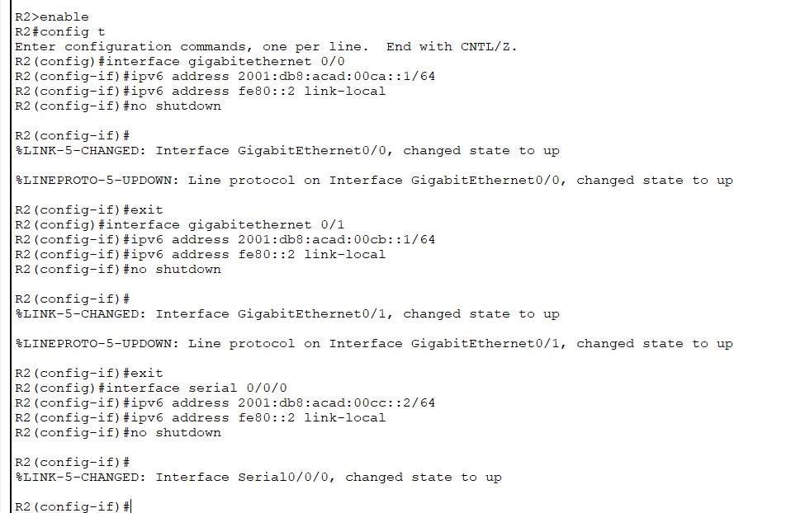

**Result-** Hence we have implemented a subnetted IPv6 Addressing Scheme .

